**Deep Learning-Based Radio Signal Classification for Low SNR and High SNR**

**Team Number 3, M. Farhan Tandia (0860814), Ivan Surya H (0860812)**

## Abstract

The ability to classify signals is an important task that holds the opportunity for many different applications. Previously to classify the signal, we should decompose the signal using FT (Fourier Transform), SIFT, MFCC, or another handcrafting method using statistical modulation features. In the past five years, we have seen rapid disruption occurring based on the improved neural network architectures, algorithms, and optimization techniques collectively known as deep learning (DL). It turns out that state of the art deep learning methods can be applied to the same problem of signal classification and shows excellent results while completely avoiding the need for difficult handcrafted feature selection. In 2018, people use ResNet as a state of the art of computer vision to classify radio communication signals. But ResNet only still fail to distinguish signal with low SNR condition. They only work well on a signal with high SNR Conditions. After two years, deep learning already improved a lot and many methods have become the new state of the art that we could apply for radio signal classification. Hence, we propose a new state of the art method to better classifying radio-signal network that both works on a signal with low noise (High SNR) and signal with high noise (Low SNR). Our works even will work using only RAW signal without the need preprocessing or denoising the noisy signal.

## Background



Rapidly understanding and labeling the radio spectrum in an autonomous way is a key enabler for spectrum interference monitoring, radio fault detection, dynamic spectrum access, opportunistic mesh networking, and numerous regulatory and defense applications. Today's military operations depend on the extensive use of wireless communication technologies. Monitoring of radio signals may reveal vital information regarding the detection, localization, and identification of an opponent. Traditionally, operators who were trained to recognize various signal formats based on manual ‘listen in’ techniques performed the identification.

For many years, radio signal classification and modulation recognition have been accomplished by carefully handcrafting specialized feature extractors for specific signal types and properties and by and deriving compact decision bounds from them using either analytically derived decision boundaries or statistical learned boundaries within low-dimensional feature spaces. Consider the image below: these are just a few of the many possible signals that a machine may need to differentiate.

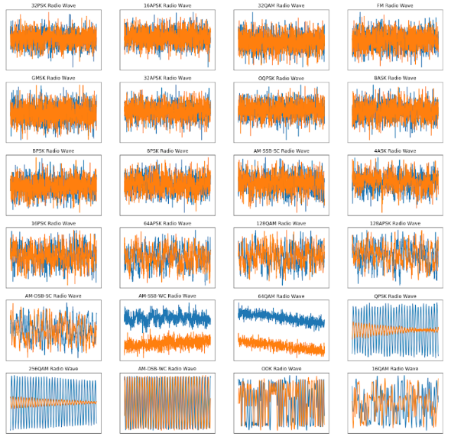

For humans, it is really difficult to differentiate the signal by a look at each signal with our eyes. Hence to classify those signals, humans need to extract some features first. The first method is using statistical modulation features. Using this method, we need to extract the structure of the carrier, symbol timing, and symbol structure for certain modulations and then move the next step of decision criterion using the machine learning method. These methods work well and successfully provide a robust classification for the signal itself. But it still needs a lot of information to classify the signal, hence it will be difficult if the information we got is not completed or one of the information is missing. The second method is Radio Channel Models, although it is easier than the first method to make a stochastic model, we still need to create the model of the signal first. We could not input the raw signal directly to our system and get the classification result.

In the past few years, **deep learning models have out-paced traditional methods in computer vision** that, like the current state of signal classification, involved meticulously creating hand-crafted feature extractors. Deep learning provides a hands-off approach that allows us to automatically learn important features directly off of the raw data. In 2018, people used the deep learning method (ResNet) to classify radio signals. They got the nice result with accuracy of almost 93% for high SNR signals. This method works even with RAW signal without hand-crafting denoising or pre-processing the signal. This then proved that Deep Learning could become new state-of-the-art in radio signal classification. The method even does not need pre-processing and de-noising every signal. But there is still some weakness, that the method is not doing good with low SNR signal (Signal with really high noise). The performance could be shown below:

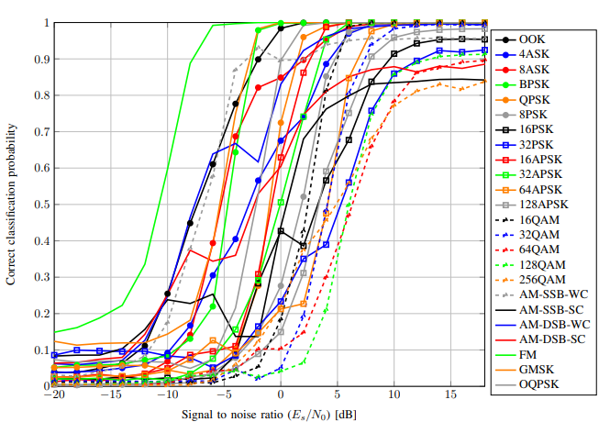

We could see from the figure that the signal classification still has the problem for classifying low SNR signal. The accuracy for certain signal under 0 dB decreases a lot, even the accuracy is under 50%. **In this proposal, we would create a new state-of-the-art method that could classify low SNR and high SNR signals with better accuracy**. The result will help a lot for classifying signals in the real condition since we will not always receive an ideal signal in real life.

## II. Problem Statement

1. **What is the new state of the art of deep learning needs to be chosen and suitable for radio signal classification?**

The latest Radio Signal Classification using Deep Learning is done in 2018. After two years there is a lot of new state-of-the-art Computer Vision including new networks, new optimization, and even a new type of regularization. We could use this new state of the art to produce more robust and more efficient communication signal classification.

1. **How we could make use of a large dataset to classify the RAW signal using the new state of the art of deep learning network?**

We use a dataset from DeepSig that contains the representation of many different kinds of communication signals. This dataset contains both clean signals and noisy signals. In real life, the signal always not in the ideal state, we could not mimic clean signal directly for this classification, because the model created from clean signal only will be difficult to recognize the signal in daily life. We need to process the datasets and make a selection from the dataset also make use of the noisy signal to get the representation of signal both in low SNR and high SNR conditions.

1. **How we could get higher accuracy to classify signals both in low SNR and high SNR?**

Some of the previous work still not good to classify signal in Low SNR, it means that if the noise is higher, the model will likely to be failed to do the classification. With the new state of the art of computer vision, we would improve the works, so it will possible to classify signals with high noise without compromise the accuracy for the signal with low noise.

## III. Challenges

1. In reality, the signal is always not ideal and combined with the unwanted signal that is considered as noise. In the image above, we can see how drastically noise can affect our ability to recognize a signal.

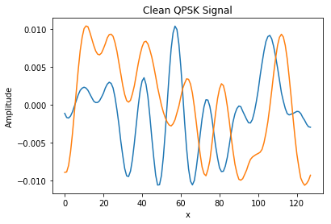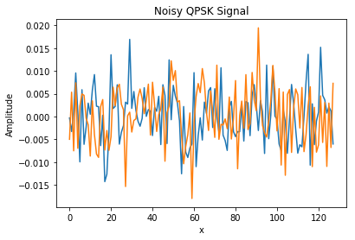

1. A clean signal will have a high SNR and a noisy signal will have a low SNR. We should be able to classify signals both in low SNR and high SNR using the RAW signal without preprocessing needed. Denoising or preprocessing many kinds of signal is not an easy task, because some signal needs different treatment in case of preprocessing, sometimes we could not do the preprocessing to the signal that we do not know what the signal is. Hence, one of the challenges is how we could classify the RAW signal directly.

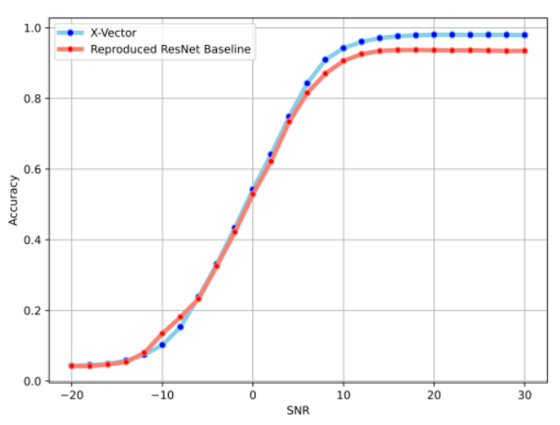

1. We use the DeepSig Radio Signal Dataset, this dataset is pretty large (18GB) with consists 24 types of signal modulation such as 32PSK,16APSK, 32QAM,FM,GMSK, 32APSK, OQPSK, 8ASK, BPSK, 8PSK, AM-SSB-SC, 4ASK, 16PSK, 64APSK, 128QAM,128APSK, AM-DSB-SC, AM-SSB-WC, 64QAM, QPSK, 256QAM, AM-DSB-WC, OOK, and 16QAM . We need to determine what is the best network that could classify both low and high SNR signals faster.

## III. Goal

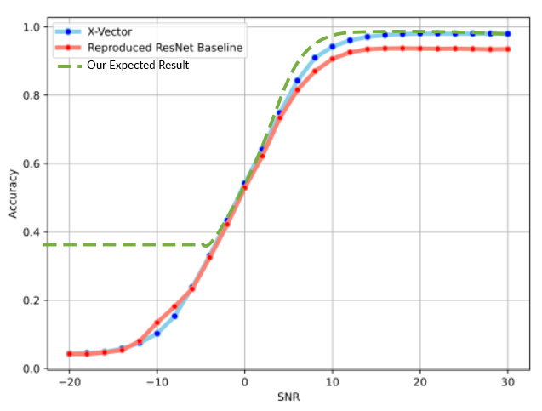

Get a comparable result

On High SNR

Increase Low SNR

Classification Accuracy.

Our Expected Result compare to the SOTA

Previous research using ResNet already got good accuracy in case of classifying ideal signal with less noise. But ResNet still has low performance in case of classifying signal with high noise. In a real application, we could not always hope that we will receive an ideal signal with low noise, we also often receive a signal with high noise. That is why our goals will be focused on classifying signals both in low and high SNR. Here is the summary of our goals:

* + - * Our target is to **get better accuracy in lower SNR signals without sacrifice accuracy in** **higher SNR signals**. It will indicate that our model is robust under the noisy signal modulation. Then our method could be used in real-condition where we do not always receive an ideal clear signal without noise.
* We will design a new deep learning architecture and try **to get comparable results in terms of accuracy with state of the art or even better.**
* Our deep learning method **will use the RAW signal directly as an input**, since preprocessing and denoise the signal needs different treatment according to what kind of signal is. Hence, in some cases, we could not always use the preprocessed signal as our input.

## References

T. J. O’Shea, T. Roy, and T. C. Clancy, "Over-the-Air Deep Learning-Based Radio Signal Classification," in *IEEE Journal of Selected Topics in Signal Processing*, vol. 12, no. 1, pp. 168-179, Feb. 2018, DOI: 10.1109/JSTSP.2018.2797022.

A. J. Uppal, M. Hegarty, W. Haftel, P. A. Sallee, H. Brown Cribbs, and H. H. Huang, "High-Performance Deep Learning Classification for Radio Signals," *2019 53rd Asilomar Conference on Signals, Systems, and Computers*, Pacific Grove, CA, USA, 2019, pp. 1026-1029, DOI: 10.1109/IEEECONF44664.2019.9048897.

S. Huang et al., "Automatic Modulation Classification Using Compressive Convolutional Neural Network," in IEEE Access, vol. 7, pp. 79636-79643, 2019, DOI: 10.1109/ACCESS.2019.2921988.

Huynh-The, Thien & Hua, Cam-Hao & Pham, Quoc-Viet & Kim, Dong-Seong. (2020). MCNet: An Efficient CNN Architecture for Robust Automatic Modulation Classification. IEEE Communications Letters. 24. 811-815. 10.1109/LCOMM.2020.2968030.